**PROLOG QUESTIONS – PART 2**

1)

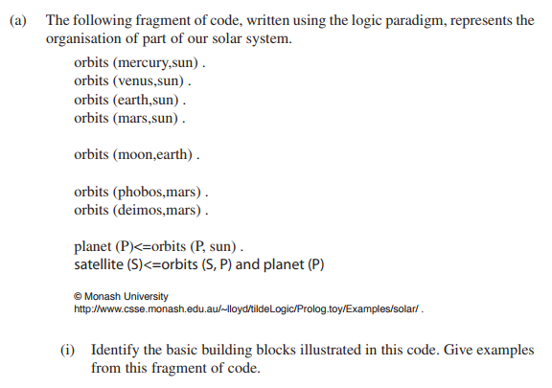

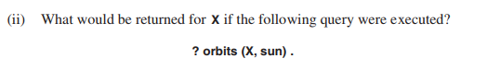

2)

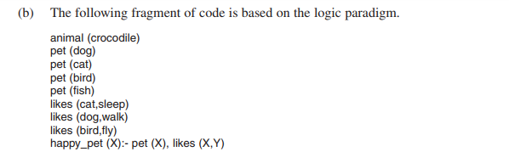

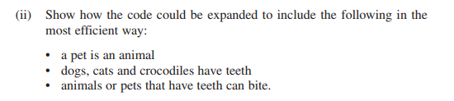

3)

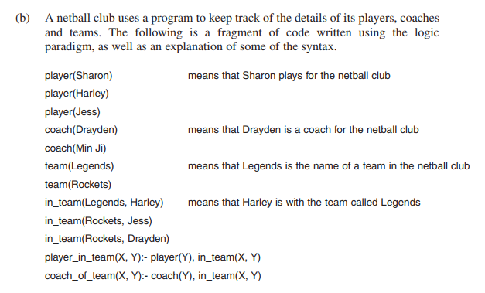

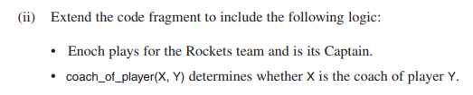

4)

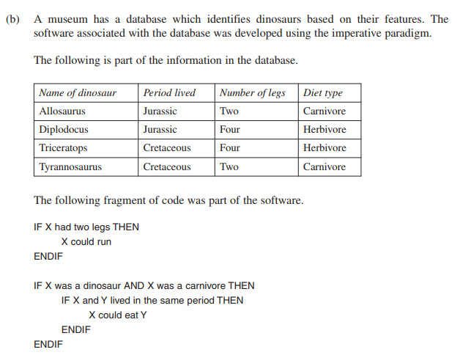



Fact 1:

Fact 2:

Rule 1:

Rule 2:

5)

